Economics of Salary Caps
It started innocently enough. A chance comment heard on the sports radio WFAN from Baltimore opened to my eyes to something I hadn’t never realized.

Under its collective bargaining agreement, each NBA team must spend up to at least 90% percent of the salary cap on player salaries. To quote the Wikipedia article on the NBA salary cap:
<To ensure the players get their share of the BRI [basketball-related income], teams are required to spend 90 percent of the salary cap each year,…>
which amounts to a minimum salary level per team of $98.226 million (see NBA Salary Cap set at $109.14 million for 2019-20 for additional details).

The WFAN Big Bad Morning Show continued on this topic for a couple of minutes but the bad taste it left in my mouth remained at lot longer. One of the announcers (Jerry Coleman) was indignant in the discussion, pointing out that the majority of the players are mediocre at best and were grossly overpaid as a result. The other two announcers (Ed Norris and Rob Long) leapt to the defense of the players, pointing out that the league makes money off of them and that it was only fair that they got a substantial piece of the pie because they were the ones putting in all the effort.
Now I don’t expect a lot of rigorous economics analysis from sports radio and I realize that hotly debated opinions make for good radio. That said, the faulty economics on display can’t go unchallenged for precisely the reason we would criticize any group claiming the earth was flat. Eventually this bad thinking leads to bad decisions. Sadly, both Jerry’s and Ed’s & Rob’s points-of-view are wrong and make good examples of the kind of ‘flat earth’ thinking so prevalent in the way the public at large think about economics issues. First let’s deal with Gerry’s misconceptions and then we’ll discuss the more subtle errors of Rob and Ed.
Gerry’s primary error is in thinking the common misconception that there is a single unique standard for judging what a person’s effort is worth. I might agree with him that the majority of professional basketball players fall short of really having a mastery of the game. Examples are abundant where a player confuses athleticism with understanding the core aspects of the game. As a result there are moments of exhilaration but they are often few and far between and, it often is the case, that the team, as a whole, suffers from the grandstanding of one of these players. I might even go so far as to say that I think the NBA as a whole is not worth it. But in these cases Gerry and I are merely stating opinions and not well-supported ones. The public judges a basketball player on the enjoyment they derive from watching him play not from some objective analysis of how he plays. Since it is a matter of taste in entertainment, there is no absolute scale against which he can be measured, no well-defined set of criteria by which we can say that he deserves such and such and no more. He gets what the market can bear even if someone schooled in the art of basketball would find issues with the skills (or lack thereof) on display. If the public enjoys a particular player’s flamboyance and are will to look past his shortcomings then they are getting exactly what they pay for and their freedom to choose should be as sacrosanct as those who think that the player is ‘shockingly overpaid’.
Rob’s and Ed’s error centers more along the economic fallacies pointed out by Frederick Bastiat, when the latter complained about people ignoring the unseen cost. It is tempting to look at the players and couches putting in the effort at playing while the owners simply prowl the sidelines or sit comfortably in the luxury owner’s box and say only one side is working. But, of course, this looks past the time and effort put in by the owners in acquiring the capital to buy a team. Such thinking ignores the league management that markets the games and makes deals with the networks to air each contest. For one thing is certain, no matter how talented an individual player is his talent amounts to nothing if there isn’t an audience willing to buy the product he is selling. Without access to a market to showcase his skills he is consigned to suffer in obscurity. This is the point so brilliantly made by Crash Davis (played by Kevin Costner) in the pool hall scene of Bull Durham.
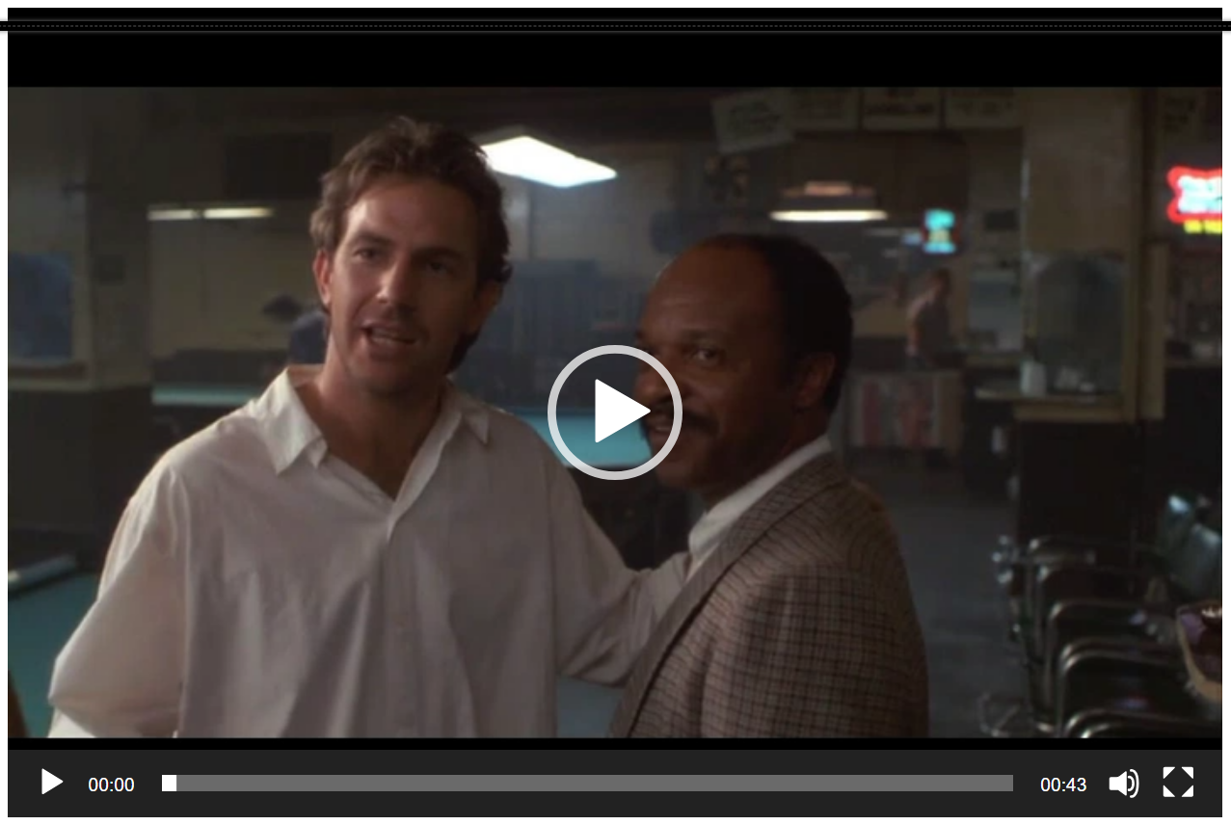
The benefits the players derive from the structure of the league and the center stage it provide them extend far beyond the salary they are paid. Many players earn substantial incomes by lending their endorsements or likenesses to advertising this product or that. Do the owners get a piece of this pie in exchange? Shouldn’t the flow of earnings go both way since the players endorsement revenue results only from the fame they derive from playing in the NBA?
To close, I don’t think one simple morning show will bring down the fabric of capitalism nor do I think that Gerry, Ed, and Rob are responsible for these misconceptions being part and parcel of ordinary thinking. But they could contribute to better thinking about economics issues. As far as the NBA is concerned, it is hard not to be critical of squabbling millionaires bickering with squabbling billionaires. Both sides have a lot to be thankful for but I somehow think that even during this time of thanksgiving, neither side is likely to recognize much less admit it.

